Affine Transformations
An affine transformation is a transformation $T:R^{2}→R^{2}$, defined by
$$T\left(\vec{x}\right)=A\vec{x}+\vec{a} ; ∀x∈R^{2}$$
For some $a∈R^{2}$, where $A$ is $2×2$ invertible matrix i.e. $AA^{-1}=I.$
Remarks:
1. Every orthogonal matrix is invertible but an invertible matrix may or may not be orthogonal.
- Euclidean geometry is a subset of affine geometry or Affine transformations are the generalization of Euclidean transformation.
Types of Affine transformation:
- Scaling, 2- Stretching, 3- Shearing
- Scaling
A transformation $T:R^{2}→R^{2}$, defined by:
$$T\left(\vec{x}\right)=A\vec{x}; ∀x∈R^{2}$$
Where
$$A=\left[\begin{matrix}k & 0 \\ 0 & k\end{matrix}\right]$$
Is said to be a scaling by the factor k.
Note: 1. If k>1, then its dilation/enlargement.
- If $0≤k≤1,$then its contraction.
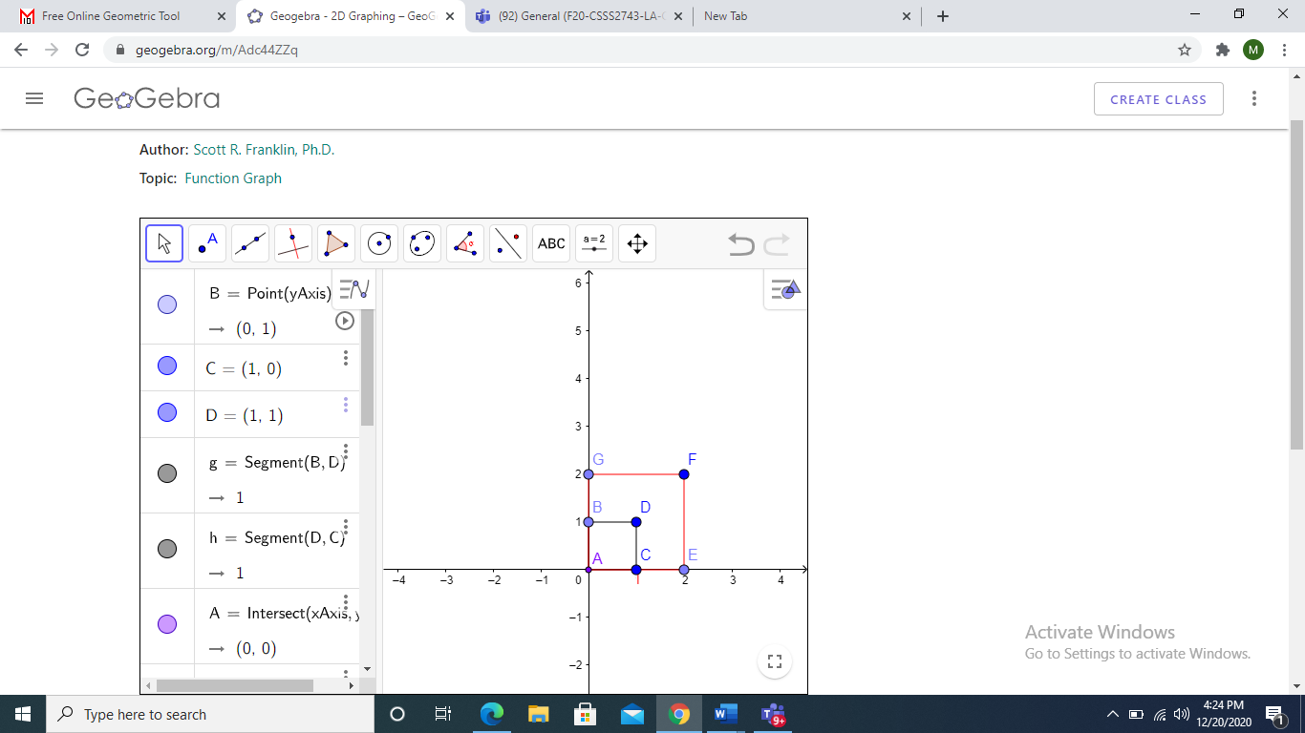
Example 1: (Scaling of Square)
A square with vertices $\left(0, 0\right), \left(0,1\right), \left(1, 0\right), (1,1)$. Scale this square by factor 2.
Solution: As $T(\vec{x})=A\vec{x}:∀ \vec{x}∈R^{2}$
$$T\left[\begin{aligned}0 \\ 0\end{aligned}\right]=\left[\begin{matrix}2 & 0 \\ 0 & 2\end{matrix}\right]\left[\begin{aligned}0 \\ 0\end{aligned}\right]=\left[\begin{aligned}0 \\ 0\end{aligned}\right]$$
$$T\left[\begin{aligned}0 \\ 1\end{aligned}\right]=\left[\begin{matrix}2 & 0 \\ 0 & 2\end{matrix}\right]\left[\begin{aligned}0 \\ 1\end{aligned}\right]=\left[\begin{aligned}0 \\ 2\end{aligned}\right]$$
$$T\left[\begin{aligned}1 \\ 0\end{aligned}\right]=\left[\begin{matrix}2 & 0 \\ 0 & 2\end{matrix}\right]\left[\begin{aligned}1 \\ 0\end{aligned}\right]=\left[\begin{aligned}2 \\ 0\end{aligned}\right]$$
$$T\left[\begin{aligned}1 \\ 1\end{aligned}\right]=\left[\begin{matrix}2 & 0 \\ 0 & 2\end{matrix}\right]\left[\begin{aligned}1 \\ 1\end{aligned}\right]=\left[\begin{aligned}2 \\ 2\end{aligned}\right]$$
Example 2: (Scaling of Line)
Let $y=2x+3$ be a line. Determine the image of this line under the scaling by factor 3.
Solution:As $T(\vec{x})=A\vec{x}:∀ \vec{x}∈R^{2}$
$$T\left[\begin{aligned}x \\ y\end{aligned}\right]=\left[\begin{matrix}3 & 0 \\ 0 & 3\end{matrix}\right]\left[\begin{aligned}x \\ y\end{aligned}\right]=\left[\begin{aligned}3x \\ 3y\end{aligned}\right]$$
$$\left[\begin{aligned}x' \\ y'\end{aligned}\right]=\left[\begin{aligned}3x \\ 3y\end{aligned}\right]$$
$\left\{\begin{aligned}x^{'}=3x \\ y^{'}=3y\end{aligned}\right.$ $⟹\left\{\begin{aligned}x=\frac{x^{'}}{3} \\ y=\frac{y^{'}}{3}\end{aligned}\right.$
Put value of $x$ and $y$in original equation of line:$y=2x+3,$
And get the equation of scaled line with factor 3.
$$y^{'}=2x^{'}+9$$
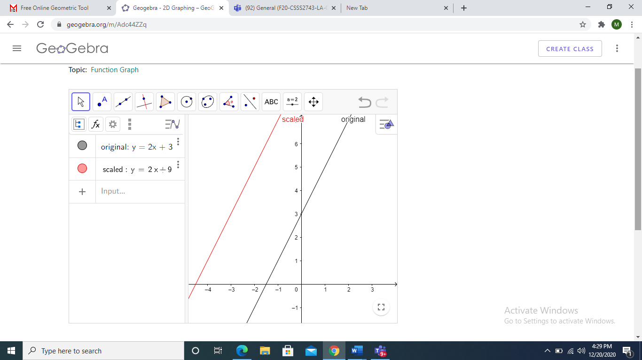
Example 3: (Scaling of Circle)
Determine the image of the circle
$${\left(x-2\right)}^{2}+{\left(y-3\right)}^{2}=4$$
under the scaling by factor 2.
Solution: As $T\left(x\right)=Ax:∀ x∈R^{2}$
$$T\left[\begin{aligned}x \\ y\end{aligned}\right]=\left[\begin{matrix}2 & 0 \\ 0 & 2\end{matrix}\right]\left[\begin{aligned}x \\ y\end{aligned}\right]$$
$$\left[\begin{aligned}x' \\ y'\end{aligned}\right]=\left[\begin{aligned}2x \\ 2y\end{aligned}\right]$$
$\left\{\begin{aligned}x^{'}=2x \\ y^{'}=2y\end{aligned}\right.$ $⟹\left\{\begin{aligned}x=\frac{x^{'}}{2} \\ y=\frac{y^{'}}{2}\end{aligned}\right.$
Put value of $x$ and $y$in original equation of circle:${\left(x-2\right)}^{2}+{\left(y-3\right)}^{2}=4$, implies
$${\left(x^{'}-4\right)}^{2}+{\left(y^{'}-6\right)}^{2}=16$$
This is the equation of circle by factor 2.
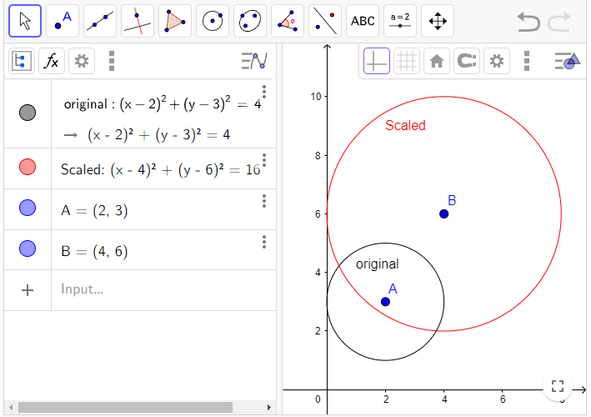
Example 5: (Scaling of an Ellipse)
Determine the image of an ellipse
$$\frac{x^{2}}{4^{2}}+\frac{y^{2}}{2^{2}}=1$$
under the transformation of scaling by factor 2.
Solution: As $T\left(x\right)=Ax:∀ x∈R^{2}$
$$T\left[\begin{aligned}x \\ y\end{aligned}\right]=\left[\begin{matrix}2 & 0 \\ 0 & 2\end{matrix}\right]\left[\begin{aligned}x \\ y\end{aligned}\right]$$
$$\left[\begin{aligned}x' \\ y'\end{aligned}\right]=\left[\begin{aligned}2x \\ 2y\end{aligned}\right]$$
$\left\{\begin{aligned}x^{'}=2x \\ y^{'}=2y\end{aligned}\right.$ $⟹\left\{\begin{aligned}x=\frac{x^{'}}{2} \\ y=\frac{y^{'}}{2}\end{aligned}\right.$
Put value of $x$ and $y$in original equation of ellipse and get an ellipse scaled by factor 2.
$$\frac{x^{'2}}{64}+\frac{{y'}^{2}}{16}=1$$
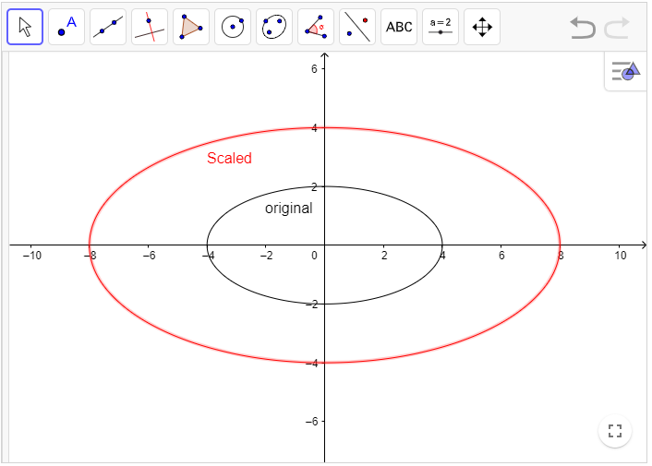
Practice Problems
Q1. Find the Image of a triangle with vertices A= (2, 2), B = (4, 3), C = (5,5), when these are scaled by factor 2.
Q2. Find the Image of line$y=2x+5$ under the transformation of scaling by factor 3.
Q3. Find the image of an ellipse $\frac{{\left(x-2\right)}^{2}}{4}+\frac{{\left(y-3\right)}^{2}}{9}=1$under the transformation of scaling by factor 2.
2-Stretching
A transformation $T:R^{2}→R^{2}$ defined by,
$T\left(\vec{x}\right)=A\vec{x}; ∀\vec{x}∈R^{2}$
Is said to be stretching along x-axis by factor k if
$$A=\left[\begin{matrix}k & 0 \\ 0 & 1\end{matrix}\right]$$
And along y-axis by a factor k if
$$A=\left[\begin{matrix}1 & 0 \\ 0 & k\end{matrix}\right]$$
Example 1: (Stretching of a square)
Find the image of a square with vertices $A\left(0, 0\right), B\left(1, 0\right), C\left(1, 1\right), D\left(0,1\right)$, when it is stretched along
- X-axis with factor 3.
- Y-axis with factor 2.
Solution: (along x-axis) As $T\left(\vec{x}\right)=A\vec{x}; ∀\vec{x}∈R^{2}$
$A=\left[\begin{matrix}3 & 0 \\ 0 & 1\end{matrix}\right]$
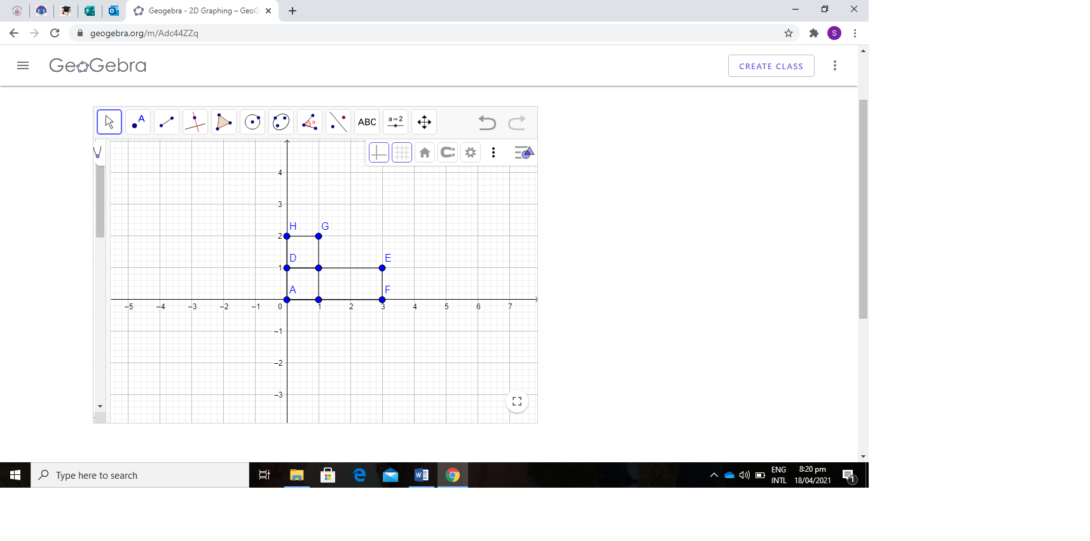
$$T\left[\begin{aligned}0 \\ 0\end{aligned}\right]=\left[\begin{matrix}3 & 0 \\ 0 & 1\end{matrix}\right]\left[\begin{aligned}0 \\ 0\end{aligned}\right]=\left[\begin{aligned}0 \\ 0\end{aligned}\right]$$
$T\left[\begin{aligned}1 \\ 0\end{aligned}\right]=\left[\begin{matrix}3 & 0 \\ 0 & 1\end{matrix}\right]\left[\begin{aligned}1 \\ 0\end{aligned}\right]=\left[\begin{aligned}3 \\ 0\end{aligned}\right]$
$T\left[\begin{aligned}1 \\ 1\end{aligned}\right]=\left[\begin{matrix}3 & 0 \\ 0 & 1\end{matrix}\right]\left[\begin{aligned}1 \\ 1\end{aligned}\right]=\left[\begin{aligned}3 \\ 1\end{aligned}\right]$
$T\left[\begin{aligned}0 \\ 1\end{aligned}\right]=\left[\begin{matrix}3 & 0 \\ 0 & 1\end{matrix}\right]\left[\begin{aligned}0 \\ 1\end{aligned}\right]=\left[\begin{aligned}0 \\ 1\end{aligned}\right]$
Along y-axis
As $T\left(\vec{x}\right)=A\vec{x}; ∀\vec{x}∈R^{2}$
$$A=\left[\begin{matrix}1 & 0 \\ 0 & 2\end{matrix}\right]$$
$T\left[\begin{aligned}0 \\ 0\end{aligned}\right]=\left[\begin{matrix}1 & 0 \\ 0 & 2\end{matrix}\right]\left[\begin{aligned}0 \\ 0\end{aligned}\right]=\left[\begin{aligned}0 \\ 0\end{aligned}\right]$
$T\left[\begin{aligned}1 \\ 0\end{aligned}\right]=\left[\begin{matrix}1 & 0 \\ 0 & 2\end{matrix}\right]\left[\begin{aligned}1 \\ 0\end{aligned}\right]=\left[\begin{aligned}1 \\ 0\end{aligned}\right]$
$T\left[\begin{aligned}1 \\ 1\end{aligned}\right]=\left[\begin{matrix}1 & 0 \\ 0 & 2\end{matrix}\right]\left[\begin{aligned}1 \\ 1\end{aligned}\right]=\left[\begin{aligned}1 \\ 2\end{aligned}\right]$
$T\left[\begin{aligned}0 \\ 1\end{aligned}\right]=\left[\begin{matrix}1 & 0 \\ 0 & 2\end{matrix}\right]\left[\begin{aligned}0 \\ 1\end{aligned}\right]=\left[\begin{aligned}0 \\ 2\end{aligned}\right]$
Example 2: (Stretching of triangle)
Find the image of a triangle with vertices $A\left(1, 1\right), B\left(4, 1\right), C\left(3, 4\right)$, when it is stretched along
- X-axis with factor $\frac{3}{2}$.
- Y-axis with factor $\frac{1}{2}$.
Solution: (along x-axis) As $$T\left(\vec{x}\right)=A\vec{x}; ∀\vec{x}∈R^{2}$$
$$A=\left[\begin{matrix}\frac{3}{2} & 0 \\ 0 & 1\end{matrix}\right]$$
$$T\left[\begin{aligned}1 \\ 1\end{aligned}\right]=\left[\begin{matrix}\frac{3}{2} & 0 \\ 0 & 1\end{matrix}\right]\left[\begin{aligned}1 \\ 1\end{aligned}\right]=\left[\begin{aligned}\frac{3}{2} \\ 1\end{aligned}\right]$$
$$T\left[\begin{aligned}4 \\ 1\end{aligned}\right]=\left[\begin{matrix}\frac{3}{2} & 0 \\ 0 & 1\end{matrix}\right]\left[\begin{aligned}4 \\ 1\end{aligned}\right]=\left[\begin{aligned}6 \\ 1\end{aligned}\right]$$
$$T\left[\begin{aligned}3 \\ 4\end{aligned}\right]=\left[\begin{matrix}\frac{3}{2} & 0 \\ 0 & 1\end{matrix}\right]\left[\begin{aligned}3 \\ 4\end{aligned}\right]=\left[\begin{aligned}\frac{9}{2} \\ 4\end{aligned}\right]$$
Along y-axis: As $$T\left(\vec{x}\right)=A\vec{x}; ∀\vec{x}∈R^{2}$$
$$A=\left[\begin{matrix}1 & 0 \\ 0 & \frac{3}{2}\end{matrix}\right]$$
$$T\left[\begin{aligned}1 \\ 1\end{aligned}\right]=\left[\begin{matrix}1 & 0 \\ 0 & \frac{3}{2}\end{matrix}\right]\left[\begin{aligned}1 \\ 1\end{aligned}\right]=\left[\begin{aligned}1 \\ \frac{3}{2}\end{aligned}\right]$$
$$T\left[\begin{aligned}4 \\ 1\end{aligned}\right]=\left[\begin{matrix}1 & 0 \\ 0 & \frac{3}{2}\end{matrix}\right]\left[\begin{aligned}4 \\ 1\end{aligned}\right]=\left[\begin{aligned}4 \\ \frac{3}{2}\end{aligned}\right]$$
$$T\left[\begin{aligned}3 \\ 4\end{aligned}\right]=\left[\begin{matrix}1 & 0 \\ 0 & \frac{3}{2}\end{matrix}\right]\left[\begin{aligned}3 \\ 4\end{aligned}\right]=\left[\begin{aligned}3 \\ 6\end{aligned}\right]$$
Example 3: (Stretching of Circle)
Let ${(x-2)}^{2}+{(y-1)}^{2}=4$ be a circle. Find its equation and image under stretching along x-axis by factor 2.
Solution: As $$T\left(\vec{x}\right)=A\vec{x}; ∀\vec{x}∈R^{2}$$
$$T\left[\begin{aligned}x \\ y\end{aligned}\right]=\left[\begin{matrix}2 & 0 \\ 0 & 1\end{matrix}\right]\left[\begin{aligned}x \\ y\end{aligned}\right]$$
$$\left[\begin{aligned}x^{'} \\ y^{'}\end{aligned}\right]=\left[\begin{aligned}2x \\ y\end{aligned}\right]$$
$\left\{\begin{aligned}x^{'}=2x \\ y^{'}=y\end{aligned}\right.$ $⟹\left\{\begin{aligned}x=\frac{x^{'}}{2} \\ y=y'\end{aligned}\right.$
Put value of $x$ and $y$in original equation of circle and get
$$\frac{{\left(x^{'}-4\right)}^{2}}{16}+\frac{{\left(y^{'}-1\right)}^{2}}{4}=1$$
It represents the ellipse.
Practice Problems
Q1. Let ${(x-2)}^{2}+{(y-1)}^{2}=4$ be a circle. Find its equation and image under stretching along Y-axis by factor $\frac{3}{2}$.
Q2. Find the stretching of an ellipse $\frac{{\left(x-4\right)}^{2}}{16}+\frac{{\left(y-1\right)}^{2}}{4}=1$ along x-axis by factor 2.
Q3. Find the image of a triangle with vertices $A\left(1, 1\right), B\left(4, 2\right), C\left(2, 3\right)$, when it is stretched along
- X-axis with factor 3
- Y-axis with factor $1$.
3- Shearing
Shearing of a point along x-axis by factor k can be defined as:
The movement of point parallel to x-axis keeping the distance of the point from the x-axis. i.e. the movement of point parallel to x-axis depending upon the y-component of the point.
- Shearing at a point along x-axis by factor k in the matrix form can be represented as
$$T\left(\vec{x}\right)=A\vec{x}; ∀\vec{x}∈R^{2}$$
Where
$$A=\left[\begin{matrix}1 & k \\ 0 & 1\end{matrix}\right]$$
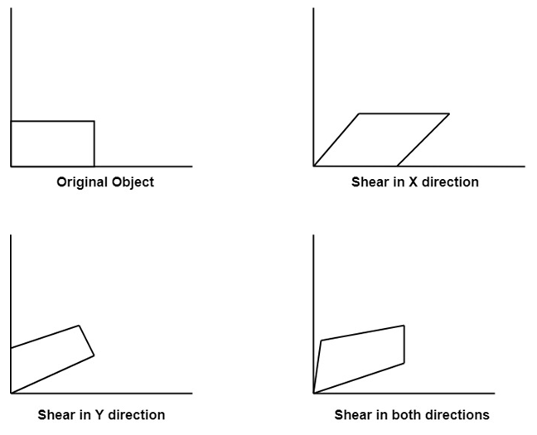

Example 1: (Shearing of vector)
Shear a point $A=(5,3)$ along x-axis by the factor 2.
Solution: As $$T\left(\vec{x}\right)=A\vec{x}; ∀\vec{x}∈R^{2}$$
$$T\left[\begin{aligned}x \\ y\end{aligned}\right]=\left[\begin{matrix}1 & k \\ 0 & 1\end{matrix}\right]\left[\begin{aligned}x \\ y\end{aligned}\right]=\left[\begin{aligned}x+ky \\ y\end{aligned}\right]$$
$$T\left[\begin{aligned}5 \\ 3\end{aligned}\right]=\left[\begin{matrix}1 & 2 \\ 0 & 1\end{matrix}\right]\left[\begin{aligned}5 \\ 3\end{aligned}\right]=\left[\begin{aligned}11 \\ 3\end{aligned}\right]$$
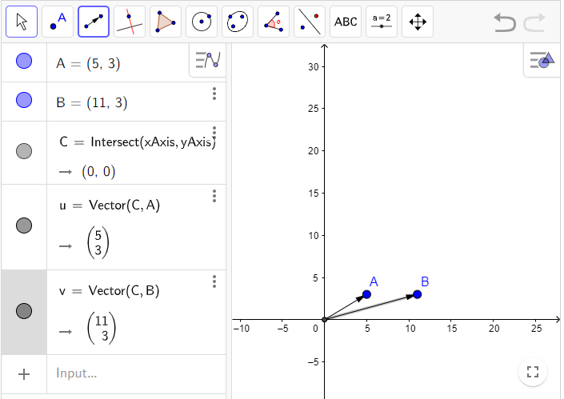
Note:
- A transformation that slants the shape of an object is called the shear transformation.
- Shearing of an object along y-axis by factor k in matrix form can be expressed as:

$$T\left(\vec{x}\right)=A\vec{x}; ∀x∈R^{2}$$
Where
$$A=\left[\begin{matrix}1 & 0 \\ k & 1\end{matrix}\right]$$
Example 2: (Shearing of Triangle)
A triangle with vertices $\left(0, 0\right), \left(4,2\right), \left(1, 6\right)$. Find the image of triangle when it will be shear along y axis by factor 2.
Solution: As $T\left(\vec{x}\right)=A\vec{x}; ∀\vec{x}∈R^{2}$
$$T\left[\begin{aligned}0 \\ 0\end{aligned}\right]=\left[\begin{matrix}1 & 0 \\ 2 & 1\end{matrix}\right]\left[\begin{aligned}0 \\ 0\end{aligned}\right]=\left[\begin{aligned}0 \\ 0\end{aligned}\right]$$
$$T\left[\begin{aligned}4 \\ 2\end{aligned}\right]=\left[\begin{matrix}1 & 0 \\ 2 & 1\end{matrix}\right]\left[\begin{aligned}4 \\ 2\end{aligned}\right]=\left[\begin{aligned}4 \\ 10\end{aligned}\right]$$
$$T\left[\begin{aligned}1 \\ 6\end{aligned}\right]=\left[\begin{matrix}1 & 0 \\ 2 & 1\end{matrix}\right]\left[\begin{aligned}1 \\ 6\end{aligned}\right]=\left[\begin{aligned}1 \\ 8\end{aligned}\right]$$
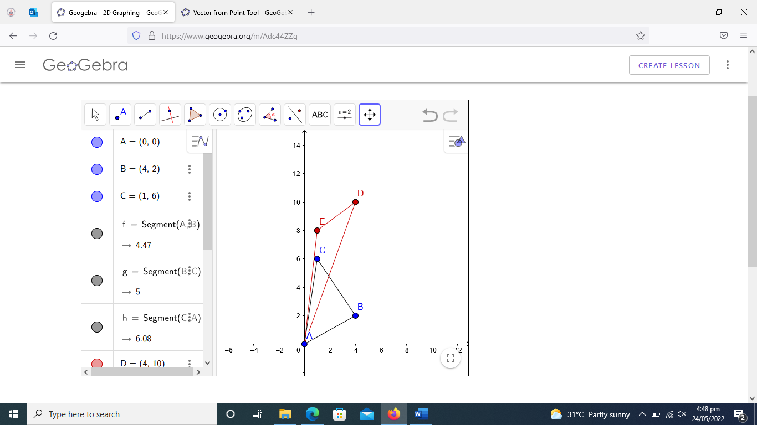
Example 3: (Shearing of Rectangle)
Consider the rectangle with vertices $\left(0, 0\right), \left(0,2\right), \left(4, 0\right), (4,2)$. Shear this rectangle along x-axis by factor 2.
Example 4: (Shearing of Rectangle)
Consider the rectangle with vertices $\left(0, 0\right), \left(0,2\right), \left(4, 0\right), (4,2)$. Shear this rectangle along y-axis by factor -3.
Example 5:
In each part describe the matrix operator corresponding to A and show it effect on unit square
- $\left[\begin{matrix}1 & 2 \\ 0 & 1\end{matrix}\right], b)\left[\begin{matrix}2 & 0 \\ 0 & 2\end{matrix}\right], c) \left[\begin{matrix}2 & 0 \\ 0 & 1\end{matrix}\right]$
Example 6: Let $x^{2}+y^{2}=4$ be a circle. Find its equation and image under the effect of shear parallel to x-axis by factor -2.
Solution: As $$T\left(\vec{x}\right)=A\vec{x}; ∀\vec{x}∈R^{2}$$
$$T\left[\begin{aligned}x \\ y\end{aligned}\right]=\left[\begin{matrix}1 & -2 \\ 0 & 1\end{matrix}\right]\left[\begin{aligned}x \\ y\end{aligned}\right]$$
$$\left[\begin{aligned}x^{'} \\ y^{'}\end{aligned}\right]=\left[\begin{aligned}x-2y \\ y\end{aligned}\right]$$
$\left\{\begin{aligned}x^{'}=x-2y \\ y^{'}=y\end{aligned}\right.$ $⇒\left\{\begin{aligned}x=x^{'}+2y' \\ y=y'\end{aligned}\right.$
Put value of $x$ and $y$in original equation of circle: $x^{2}+y^{2}=4$
We get sheared equation of circle as (an ellipse)
$$x^{'2}+5y^{'2}+4x^{'}y^{'}-4=0$$
Remarks: General equation of Conics:
$Ax^{2}+Bxy+cy^{2}+Dx+Ey+F=0$
- If $B^{2}-4AC<0, we get ellipse.$
- If $B^{2}-4AC>0, we get hyperbola.$
- If $B^{2}-4AC=0, we get parabola.$
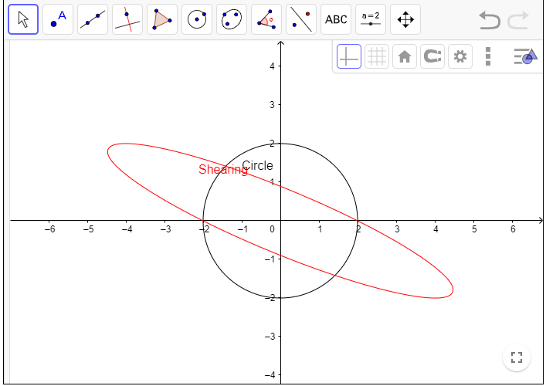

Example 6: Let ${(x+2)}^{2}+({y+1)}^{2}=4$ be a circle. Find its equation and image under the effect of shear parallel to y-axis by factor $\frac{3}{2}$.
Solution:As $$T\left(\vec{x}\right)=A\vec{x}; ∀\vec{x}∈R^{2}$$
$$T\left[\begin{aligned}x \\ y\end{aligned}\right]=\left[\begin{matrix}1 & 0 \\ \frac{3}{2} & 1\end{matrix}\right]\left[\begin{aligned}x \\ y\end{aligned}\right]$$
$$\left[\begin{aligned}x^{'} \\ y^{'}\end{aligned}\right]=\left[\begin{aligned}x \\ \frac{3}{2}x+y\end{aligned}\right]$$
$\left\{\begin{aligned}x^{'}=x \\ y^{'}=\frac{3}{2}x+y\end{aligned}\right.$ $⇒\left\{\begin{aligned}x=x^{'} \\ y=y^{'}-\frac{3}{2}x'\end{aligned}\right.$
Put value of $x$ and $y$in original equation of circle:
$${(x+2)}^{2}+({y+1)}^{2}=4$$
$$\frac{13}{4}x^{2}+y^{2}-3xy-3x+2y+1=0$$
On Comparing with General equation of Conics, we get:
$$A=\frac{13}{4}, B=-3, C=1$$
$$B^{2}-4AC={\left(-3\right)}^{2}-4\left(\frac{13}{4}\right)\left(1\right)=9-13=-4<0$$
So we get ellipse.
Example 7: Let ${(x-2)}^{2}+({y-1)}^{2}=4$ be a circle. Find its equation and image under the effect of shear parallel to x-axis by factor $2$.

Python Codes:
Example 2: Scaling, Rotation, and Shearing
import numpy as np
import matplotlib.pyplot as plt
def apply_transformation(matrix, points):
return np.dot(matrix, points.T).T
def plot_shape(points, label, color):
points = np.vstack([points, points[0]]) # Close the shape
plt.plot(points[:, 0], points[:, 1], label=label, color=color, linewidth=2)
square = np.array([[0, 0], [1, 0], [1, 1], [0, 1]])
scaling_matrix = np.array([[2, 0], [0, 2]]) # Scale x and y by 2
scaled_square = apply_transformation(scaling_matrix, square)
theta = np.pi / 4
rotation_matrix = np.array([[np.cos(theta), -np.sin(theta)],
[np.sin(theta), np.cos(theta)]])
rotated_square = apply_transformation(rotation_matrix, square)
shear_matrix = np.array([[1, 1.5], [0, 1]]) # Shear in x-direction
sheared_square = apply_transformation(shear_matrix, square)
plt.figure(figsize=(8, 8))
plot_shape(square, "Original Square", "blue")
plot_shape(scaled_square, "Scaled Square", "red")
plot_shape(rotated_square, "Rotated Square", "green")
plot_shape(sheared_square, "Sheared Square", "purple")
plt.title("Linear Transformations: Scaling, Rotation, and Shearing")
plt.axis("equal")
plt.legend()
plt.grid()
plt.show()

[1, 4], [3, 7], [5, 4]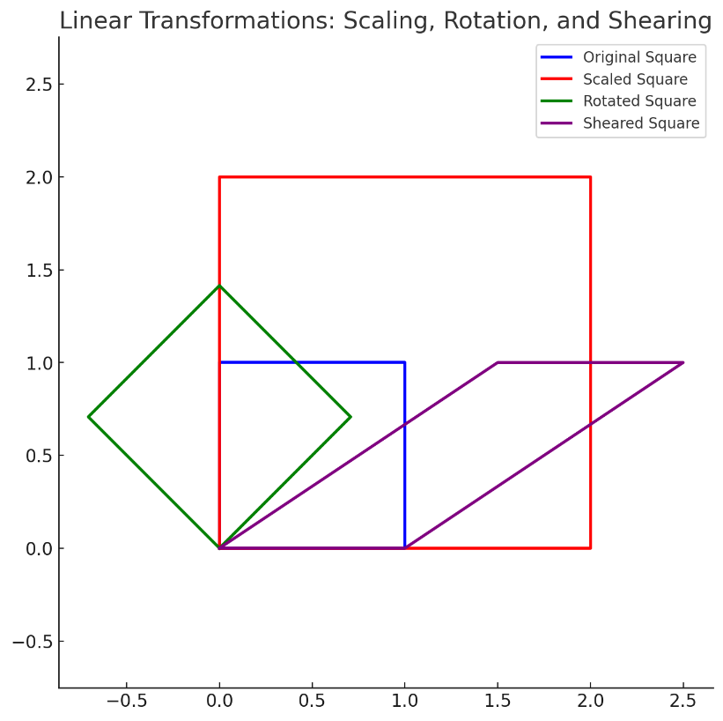

Coding Assignment
Use linear transformations to Design a House with geometric shapes (rectangles, triangles, squares, etc.).
- create a house using basic geometric shapes. For example:
A square for the body of the house with vertices [2, 0], [2, 2], [4, 2], [4, 0]
A triangle for the roof with vertices [1, 4], [3, 7], [5, 4]
A rectangle for the door with vertices [1, 0], [5, 0], [5, 4], [1, 4]
- Apply Linear Transformations:
Scaling: Scale the shapes to make the house bigger or smaller.
Rotation: Rotate the house or individual shapes.
Translation: Move the house to a different location on the plane.
- Python Code: Write Python code to perform the linear transformations using libraries like matplotlib for visualization and numpy for matrix operations.

